Antigone Notes – Images/Descriptions

Please check figure descriptions that I have compiled based on our conversation. They are very basic and I am not sure if they are correct.

I thought it would be nice to use the <figDesc> tag to describe the image visually and the <note> tag to explain how it was created, what it consists of, or even what it is supposed to mean.

Feel free to extend and amend content in any way that you see fit.
Please use different colour text so I can immediately see your alterations. Thanks.

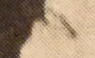
Booklet 1

01-03-img.png
<figDesc>The figure shows a woman's mouth, slightly open, with a head tilted backwards. Image is monochrome, with ochre tint.</figDesc>
<note> Image is scanned and cropped by the artist from a found book of theatre stage adaptations of Antigone.</note>

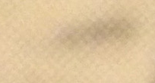
01-04-img.png
<figDesc>The figure shows a woman's mouth. Image is monochrome, with ochre tint.</figDesc>
<note> Image is scanned and cropped by the artist from a found book of theatre stage adaptations of Antigone.</note>

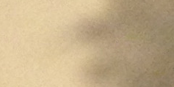
01-05-img.png
<figDesc>The figure shows a woman's mouth (frontal). Image is monochrome, with ochre tint. </figDesc>
<note>Image is scanned and cropped by the artist from a found book of theatre stage adaptations of Antigone.</note>

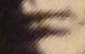
01-06-img.png
<figDesc>The figure shows a woman's mouth closed, with a head leaning slightly forward. Image is monochrome, with ochre tint. </figDesc>
<note>Image is scanned and cropped by the artist from a found book of theatre stage adaptations of Antigone.</note>

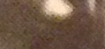
01-07-img.png
<figDesc>The figure shows a woman's mouth (from nose down to chin). Image is monochrome, with ochre tint. </figDesc>
<note>Image is scanned and cropped by the artist from a found book of theatre stage adaptations of Antigone.</note>

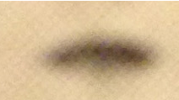
01-08-img.png
<figDesc> The figure shows a woman's mouth. Image is monochrome, with ochre tint.</figDesc>
<note>Image is scanned and cropped by the artist from a found book of theatre stage adaptations of Antigone.</note>

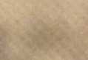
01-09-img.png
<figDesc>The figure shows a woman's mouth (nose to top of chin). Image is monochrome, with ochre tint. </figDesc>
<note>Image is scanned and cropped by the artist from a found book of theatre stage adaptations of Antigone.</note>

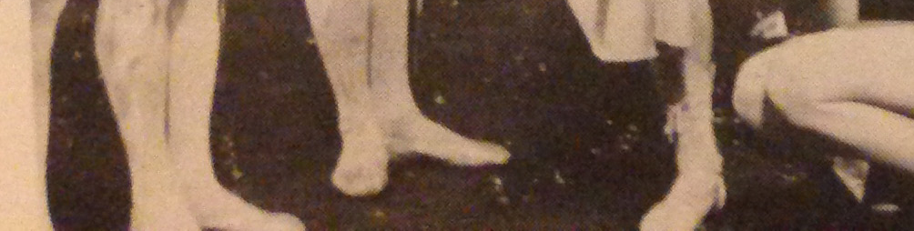
01-10-img.png
<figDesc>The figure shows four pairs of men's legs, from the sole to the knee, in a relaxed third ballet position, and a pair of women's legs, from sole to tight, crouching. They are all wearing ballet shoes and attire. From left to right, the three men are standing in a line, diagonally, one is stepping forward and the woman on the far right, seen from the side, is squatting. Image is monochrome, with ochre tint.</figDesc>
<note> Image is scanned and cropped by the artist from a found book of theatre stage adaptations of Antigone.</note>

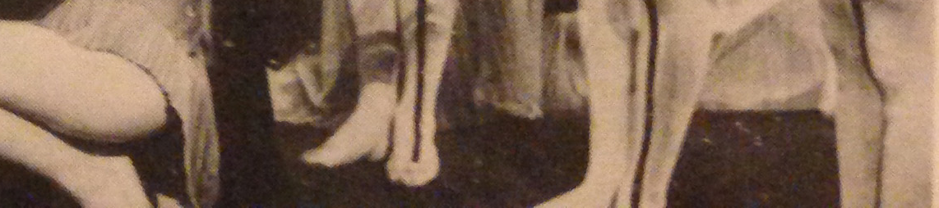
01-11-img.png
<figDesc>From right to left, the figure shows three pairs of men's legs, visible from the sole to the knee, standing in a line, diagonally, in a relaxed third ballet position, and on the left a woman, seen from the side, squatting, with dress hanging behind. They are all wearing ballet shoes and attire. Drapery is hanging behind them. Image is monochrome, with ochre tint. </figDesc>
<note>Image is scanned and cropped by the artist from a found book of theatre stage adaptations of Antigone.</note>

Booklet 2

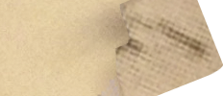
02-03-img.png
<figDesc>The figure shows a woman's mouth, slightly open. Image is monochrome, with ochre tint. Image's right corners are cropped. </figDesc>
<note>Image is scanned and cropped by the artist from a found book of theatre stage adaptations of Antigone. Image is photo edited from the <ref target="01-03-img.png">original scan</ref>.</note>

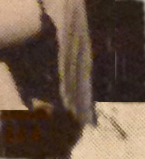
02-08-img.png
<figDesc>The figure shows a collage of two images depicting at the bottom half the <ref target="01-03-img.png">original scan</ref> of woman's mouth, slightly open, and at the top part the <ref target="01-11-img.png">original scan</ref> of a woman seen from the side, squatting, with dress hanging behind and reaching the woman's mouth below. A horizontal line divides the two image collaged together, breaking the composition at one third from the bottom. Image is monochrome, with ochre tint.</figDesc>
<note> Image is scanned and cropped by the artist from a found book of theatre stage adaptations of Antigone. Image is collaged from 2 original scans.</note>

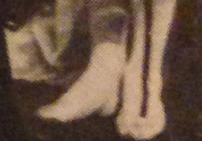
02-11-img.png
<figDesc>The figure shows a cropped segment of the <ref target="01-11-img.png">original scan</ref> of a pair of women's legs, visible from the sole to the mid calf, in a relaxed third ballet position. A dark line runs vertically in the front middle of the left leg. The woman is wearing ballet shoes and attire. Drapery is hanging behind. Image is monochrome, with ochre tint.</figDesc>
<note>Image is scanned cropped by the artist from a found book of theatre stage adaptations of Antigone.</note>

Booklet 3

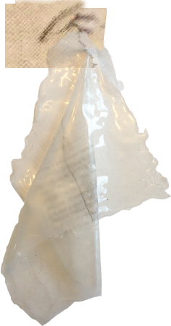
03-03-img.png
<figDesc>The figure shows two mouths holding a piece of draped sillicone. Image is monochrome, with ochre tint. </figDesc>
<note>Image is scanned cropped by the artist from a found book of theatre stage adaptations of Antigone and it is collaged together with the artist's own photography of the transparent silicone front cover of the book.</note>

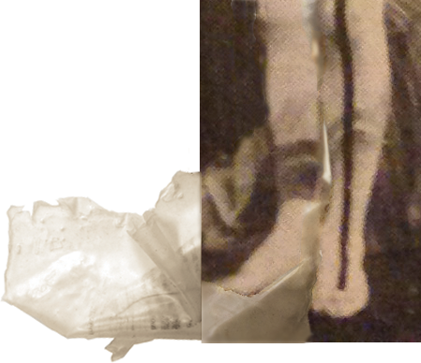
03-10-img.png
<figDesc>The figure shows a cropped segment of the <ref target="01-11-img.png"> original scan</ref> of a pair of men's legs, visible from the sole to the knee, in a relaxed third ballet position. A dark line runs vertically in the front middle of the left leg. The man is wearing ballet shoes and attire. Drapery is hanging behind. Overlaid drapery bleeds out of the bottom left side of the image. Image is monochrome, with ochre tint.</figDesc>
<note>Image is scanned cropped by the artist from a found book of theatre stage adaptations of Antigone and it is collaged together with the artist's own photography of the transparent silicone front cover of the book.</note>

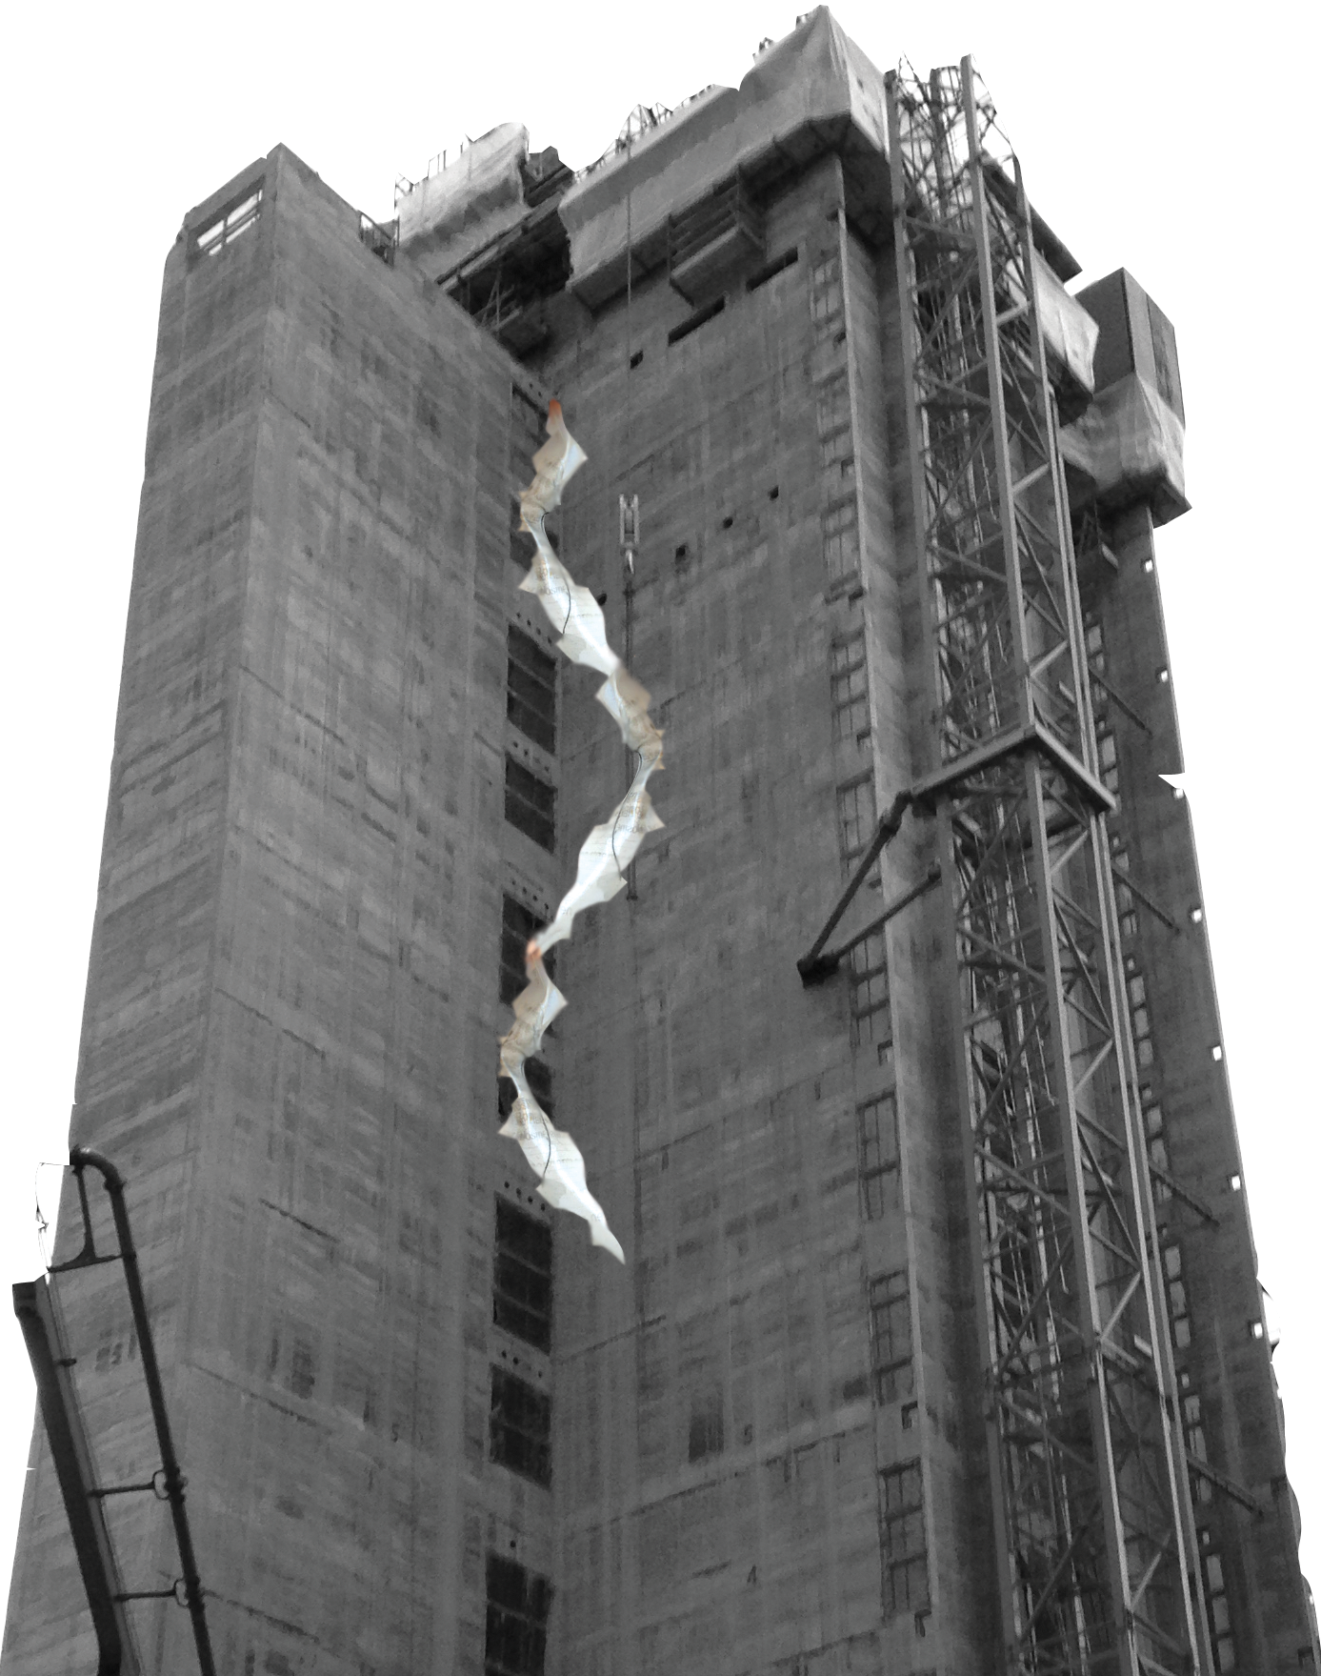
04-05-img.png
<figDesc>The figure shows an elevator shaft of unfinished thirteen story building, with scaffolding elements and a service lift on the right side. The construction is L-shaped, shot from ground level, in sharp perspective. A double S-shape in light beige and grays is collaged in the middle of the image. Image is monochrome.</figDesc>
<note>Image is artist's own photography collaged with the transparent silicone front cover of the book.</note>

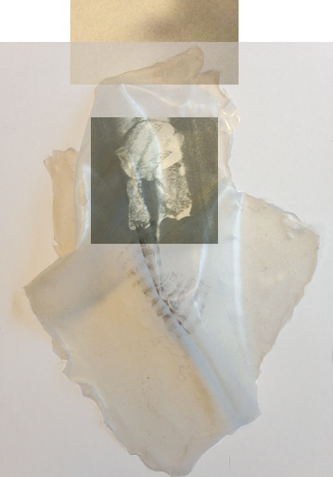
04-09-img.png
<figDesc> The figure shows the <ref target="01-05-img.png">original scan</ref> of a women's mouth (frontal), a piece of silicone hanging from underneath it, and a found image of a woman’s mouth, with ectoplasm, from a séance. Image is monochrome, with ochre tint. </figDesc>
<note>Image is scanned cropped by the artist from a found book of theatre stage adaptations of Antigone and it is collaged together with the artist's own photography of the transparent silicone front cover of the book.</note>

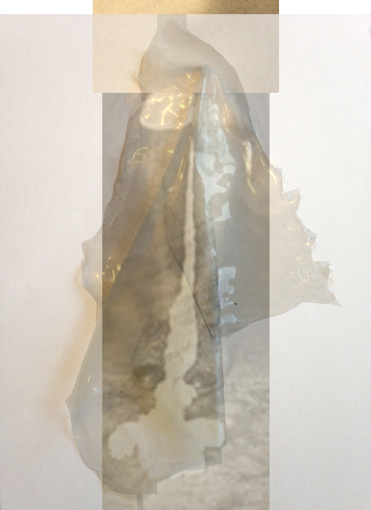
04-10-img.png
<figDesc> The figure shows the <ref target="01-05-img.png">original scan</ref> of a women's mouth (frontal) and several pieces of silicone hanging underneath and around it. Image is monochrome, with ochre tint. </figDesc>
<note>Image is scanned cropped by the artist from a found book of theatre stage adaptations of Antigone and it is collaged together with the artist's own photography of the transparent silicone front cover of the book.</note>

